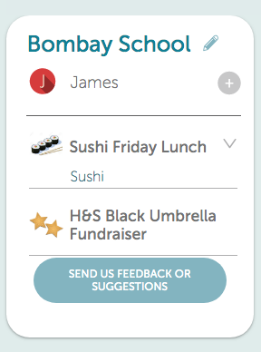
School payments online
We are excited to let you know about our Kindo online school shop! You can place your Friday Sushi lunch orders and support our Umbrella fundraiser.
It’s easy, convenient, open 24/7, and available soon on our school website.

Create your family account
It’s easy to set up your family account.
Click here for the login in page OR visit www.mykindo.co.nz.
Click on and complete the online registration form with your contact details and your child/ren’s name/s.

Topping up your account
There are a number of ways you can choose to top-up your account. This can be done at the checkout, or my selecting the ‘top up account’ icon.

Bank Transfer No fees. Allow 2 days for processing.
POLi No fees. Instant transfer. **RECOMMENDED**
Credit/Debit Card 50 cent charge + 2.5% fee. Instant transfer.
Visa / MasterCard / American Express and China UnionPay available.

Shopping
Items can be added to your shopping cart, by clicking on your child’s initial next to an item.

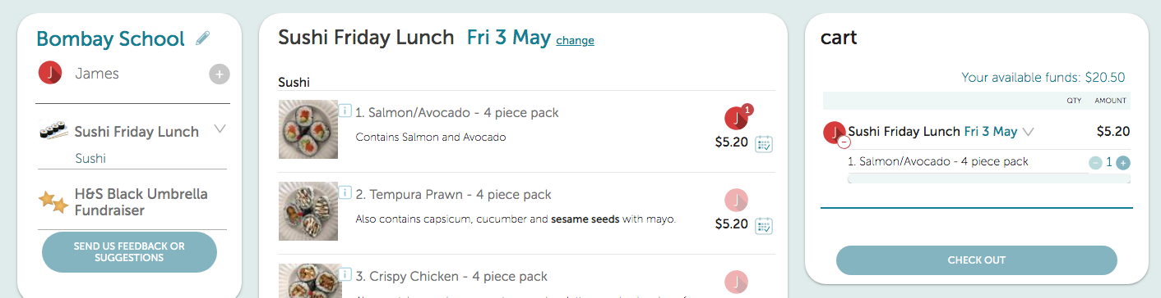
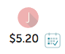
Click on the calendar icon to order the item for more than one lunch day.

Once you have made all your purchases click on to complete your transaction.
Then simply click at the checkout and you’re done!

If you have insufficient funds you will be required to top-up first to complete your transaction.
Your order will automatically go through to the school, and you will receive an email receipt confirming your payment or top-up!

See it in action
You can view our short online tutorial to see how to make your purchases – Online Tutorial
Need assistance? Call the Kindo helpdesk on free phone 0508 4 KINDO (0508 454 636), or
email hello@mykindo.co.nz.

